An Introduction to Batch Files and Scripting in Windows

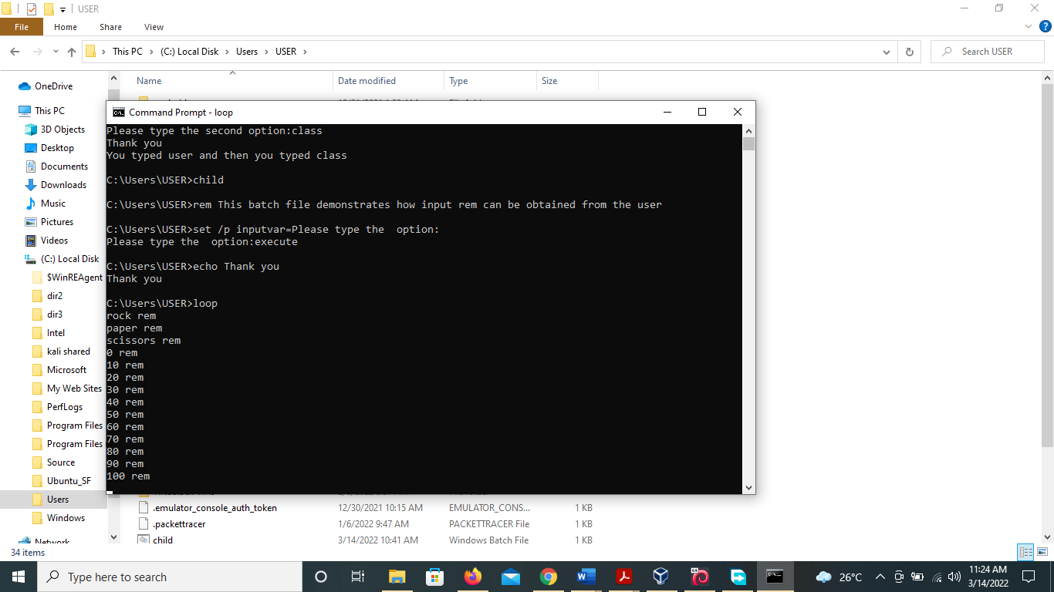

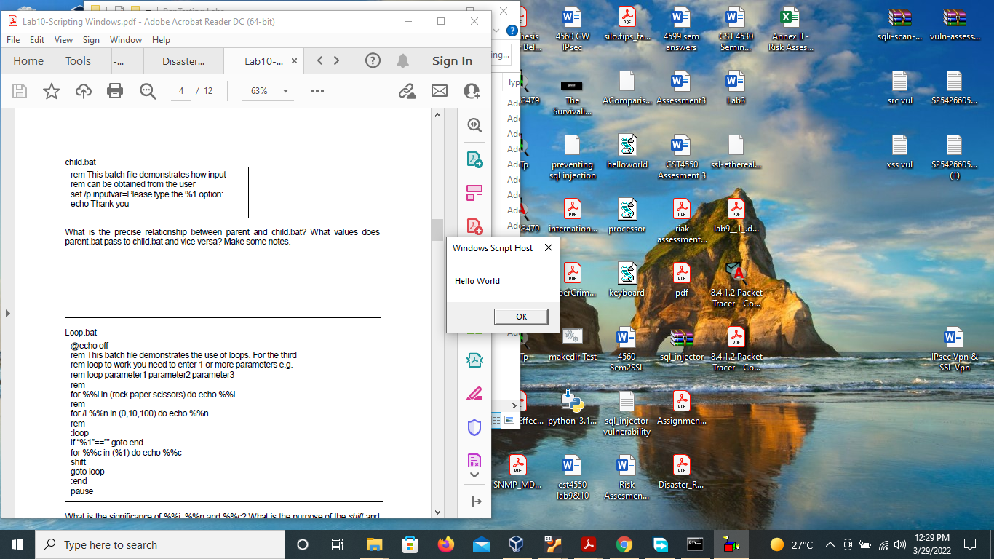

1. What is the significance of the *rem* command and the variable %1? What are the Unix equivalents of *rem* and %1?

The rem command is used to insert remarks or comments that will not be acted on into a batch file.  the UNIX equivalent of the rem is the # command.

In a script, or batch file, %1 is used to represent a variable or matched string. %1 can print what is entered after the batch file name. the UNIX equivalent of %1 is $1

1. What is the precise relationship between parent and child.bat? What values does parent.bat pass to child.bat and vice versa? Make some notes.
2. What is the significance of %%i, %%n and %%c? What is the purpose of the *shift* and *pause* commands?

Creating WSH scripts

What happens to the output from helloworld.vbs when you run it i) by double-clicking on its icon in Explorer and ii) by using cscript on the command line? Are there any advantages to running scripts from the command line rather than via the GUI?

double-clicking from desktop, opens a small screen for the script, with an output helloworld.

Whereas on CLI the output is displayed with more information about the host application and version.

